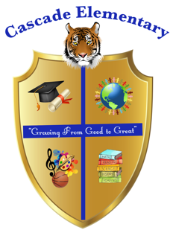

Cascade Elementary Website
Weekly Grade Level News Blast

Week of: Monday, May 4, 2020

Grade Level: 1st Grade

Standards of the Week:
Reading: ELAGSE1RL4: Identify words and phrases in stories or poems that suggest feelings or appeal to the senses.
ELAGSE1RL5: Explain major difference between texts that tell stories and texts that give information.
ELAGSE1RL6: Identify who is telling the story at various points in a text.

Math: MGSE1.G.2 Compose two-dimensional shapes (rectangles, squares, trapezoids, triangles, half circles, and quarter-circles) or three-dimensional shapes (cubes, right rectangular prisms, right circular cones, and right circular cylinders) to create a composite shape, and compose new shapes from the composite shape. This is important for the future development of spatial relations which later connects to developing understanding of area, volume, and fractions.

MGSE1.MD.4 Organize, represent, and interpret data with up to three categories; ask and answer questions about the total number of data points, how many in each category, and how many more or less are in one category than in another.

Science: S1P2. Obtain, evaluate, and communicate information to demonstrate the effects of magnets on other magnets and other objects.

Social Studies: SS1H1 Read about and describe the life of historical figures in American history.

Additional Information for Parents and Students:

- We will now only be operating our distant learning four days a week. This mean on Fridays students will not have to meet on zoom and will now only have assignments Mon.-Thurs. Please use Friday to make up any work that is missing and log on to iReady if recommended by your child’s teacher!

- We will continue having our Virtual Daily Meetings at 10:00 am. We will continue using the app Zoom which is located in mybackpack. All students are required to attend each day as we will be taking daily participation points. This will allow the students the opportunity to ask questions about any assignments or any concerns. Your child’s teacher will be reaching out to you with more information.
- Continue using google classroom to complete all daily assignments. If you have any questions please reach out to your child’s teacher.

Evelyn.hooks@atlanta.k12.ga.us
Josby@atlanta.k12.ga.us
Erin.pratt@atlanta.k12.ga.us

